Week Ending: | DAY: |  |  |  | Subject: Mathematics
Duration: 60mins per lesson |  |  |  |  | Strand: Algebra
Class: B2 | Class Size: |  |  |  | Sub Strand: Patterns And Relationship
Content Standard:  B2.2.1.1 Recognize, create, extend, describe, and use patterns and rules to solve mathematical tasks |  |  | Indicator:  B2.2.1.1.2 Identify, create and describe the rule for simple number patterns involving repeated addition or subtraction, skip counting and arrays of objects. |  |  | Lesson:  1 OF 1
Performance Indicator:  Learners can identify, create and describe the rule for simple number patterns involving repeated addition or subtraction, skip counting and arrays of objects. |  |  |  | Core Competencies:  Problem Solving skills; Critical Thinking; Justification of Ideas;
Teaching/ Learning Resources |  | Counters, patterns made from manila cards
New words
References: Mathematics Curriculum Pg. 32
DAYS | PHASE 1: STARTER | PHASE 2: MAIN | PHASE 3: REFLECTION
Monday | 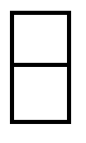Engage learners to count the dots and write each number beside  __ | Guide learners to find the missing terms in the following:  9, 1, 3, 5, 9, 1, 3, 5, ___ ; ___  __  2, 4, 6, 8, 10, ___ ; ___,  5, 10, 15, 20___ , ___ ; or  54, 55, 56, 57, ___ , ___ .  Assessment: Let learners practice with several examples | Ask learners to tell you what they have learnt  Give learners individual or home task
Tuesday | Engage Learners to sing the song  WE CAN COUNT  We class two  We can count  We count 1,2,3,4,5  We count 6,7,8,9,10  We class two can count very well. | Guide learners to find the missing terms in the following:  9, 1, 3, 5, 9, 1, 3, 5, ___ ; ___  2, 4, 6, 8, 10, ___ ; ___,  5, 10, 15, 20___ , ___ ; or  54, 55, 56, 57, ___ , ___ .  Assessment: Let learners practice with several examples | Ask learners to tell you what they have learnt  Give learners individual or home task
Wednesday | Engage learners to complete the pattern.  Which shape comes next? Draw it  __ | Guide learners to Identify and describe the rules for the following patterns  - 2, 4, 6, 8, 10, … (the rule is “add two”)  Let learners find the rules for the following patterns.  - 5, 10, 15, 20, …  - 20, 18, 16, 14, …  Assessment: Let learners practice with several examples | Ask learners to tell you what they have learnt  Give learners individual or home task
Thursday | 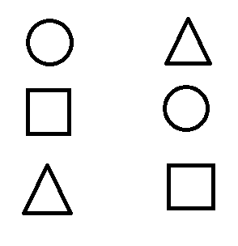have learners to match the shapes. | Guide learners to Identify and describe the rules for the following patterns  - 2, 4, 6, 8, 10, … (the rule is “add two”)  Let learners find the rules for the following patterns.  - 5, 10, 15, 20, …  - 20, 18, 16, 14, … | Ask learners to tell you what they have learnt  Give learners individual or home task
Friday | Engage learners to draw the circles and shade any three. | Guide learners to Identify and describe the rules for the following patterns  - 2, 4, 6, 8, 10, … (the rule is “add two”)  Let learners find the rules for the following patterns.  - 5, 10, 15, 20, …  - 20, 18, 16, 14, …  Assessment: Let learners practice with several examples | Ask learners to tell you what they have learnt  Give learners individual or home task

